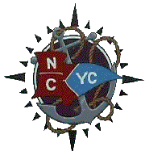
MID-CHANNEL RACE
North Cape Yacht Club
Saturday, May 28, 2023
Entry Form

Owner / Skipper _______________________________________________________________

Sail Number _______________ Yacht Name: ___________________________________
Make of Yacht: _________________________ Yacht Club: _________________________
E-Mail Address: _______________________________________
Class Entered: PHRF: __________ JAM: _________ Rating: _________________

To the fullest extent permitted by law, I hereby waive any rights I may have to sue the race organizers (organizing authority, race committee, protest committee, host club, sponsors, or any other organization or official) involved with the event with respect to personal injury or property damage suffered by myself or my crew as a result of our participation in this event and hereby release the race organizers from any liability for such injury or damage.

Owner / Skipper: ___________________________________ Date: _______________

Registration must include this form, a copy of your current PHRF rating certificate, proof of insurance if not on file at NCYC, and your entry fee of $45.00. Checks are to be made out to North Cape Yacht Club.

NCYC use:
PHRF Certificate CC of insurance Registration Fee

